**NetProbe**

Functional Specification Document

|  |  |  |  |  |  |  |  |  |  |  |
| --- | --- | --- | --- | --- | --- | --- | --- | --- | --- | --- |
| 14/05/2018 |  |  |  |  | TRANSPORT | | | | | |
| Seckou A. A. Sagna |  |  |  |
| Model | Functional | | Physics | | |
| Date | Written | Checked | Validated | Approved | Simplified |  | |  | | |
| Complete | X | |  | | |
| Confidentiality : | | | CONFIDENTIAL.  All rights reserved. All the information contained in this document belongs to ALSTOM. Reproduction, use or disclosure to third parties, without written authority, is strictly prohibited. | |  | | Rev. | | Lang. | N. Shts |
| * Confidential ___ * Highly Confidential ___ | | | A | | En |  |

# Purpose :

This document provides the functional description of the NetProbe software with the requirements of the product.

It is an open specification; therefore the used means and technology to create the product are not defined, the implementer is free to choose how to create the product and meet the specifications.

# Product Description :

NetProbe is a Test Bench and Train networks investigation software. It allows to sniff data being exchanged between devices in an Ethernet Network and gives further information about the network and the train devices. It allows tracking variables and executing various operations on them. Therefore, it should be compatible with VS service and CIP Protocol proper to Alstom.

# Specifications :

The product must meet the following requirements at delivery :

* NetProbe shall run on all Windows OS from Windows 7 ;
* NetProbe shall allow to create a new project ;
* NetProbe shall be able to investigate data traffic on both VS and CIP networks ;
* NetProbe shall be able to import junctions, groups, RMO, ECS, ICD project files ;
* NetProbe shall be able to save or save as a project for later re-use ;
* NetProbe shall allow to open existing projects and resume work on them ;
* NetProbe shall be able to display variables being exchanged on the test bench or train networks ;
* NetProbe shall be able to process variables and save them in a database ;
* NetProbe shall Allow to be selective on which variables we want to print or delete ;
* NetProbe shall allow to operate special operations on variables such as drawing one’s evolution in time or customizing its display or detecting fugitive variations ;
* NetProbe shall allow exporting the dashboard by taking a snapshot or creating a file.

# Functionalities :

The product logo has been designed and it recalls Ethernet exchanges investigation and Alstom theme.



Figure 1 : NetProbe’s Logo

The software has been creating using Windows Forms technology which is a widely used and well documented technology of Visual Basics. It allows creating windows applications with many functionalities and uses .Net Frameworks.

We used Visual Studio 2017 to create NetProbe using .Net Framework 4.6.1 which can be run in any machine with any OS version greater or equal to Windows 7.

The following paragraphs describe NetProbe’s different interfaces and their functionalities:

* Mainview : Is the main window seen at launch and allows to create a new project or open an existing project or have further information about the product version. It also allows loading or closing the Dashboard.

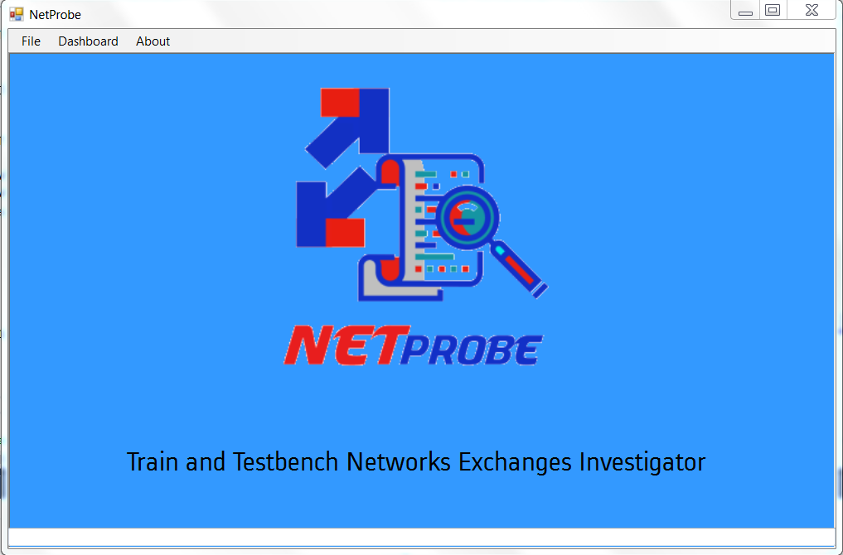

Figure 2 : NetProbe's Main view

* New Project Creation: Is the pop up window allowing to create a new project and uploading a project file. The user can name his project and indicate the location of the created project.

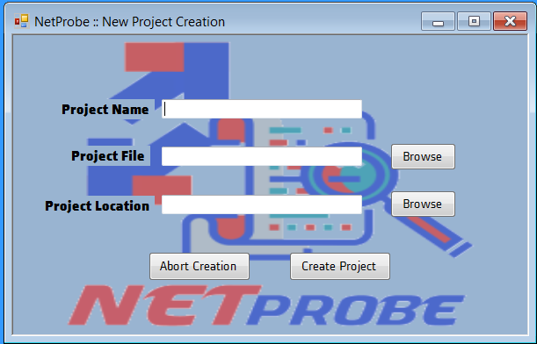

Figure 3 : New Project Creation wizard

* Dashboard : Is the window where the user can get connected to a network and observe variables being exchanged

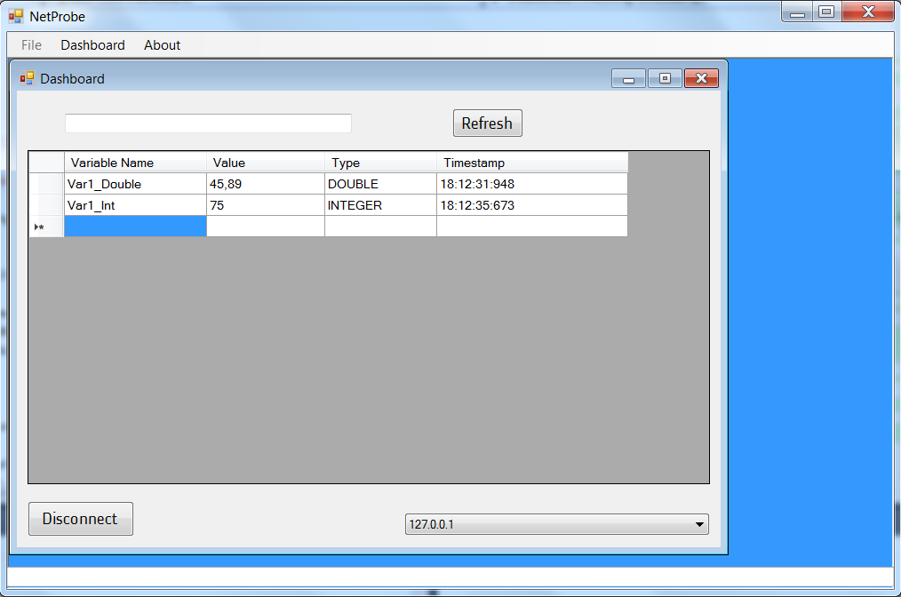

Figure 4 : NetProbe's Dashboard

# Test and Validation:

The NetProbe software has been developed using User Stories to gather all the requirements from different users. The project management method used is Agile/Scrum and in each sprint are realized predefined user stories.

The following board shows tests and results done at the end of each sprint:

* Sprint 1 :

Figure 5 : Test 1 done at the end of Sprint 1